**TEMS AFTER SCHOOL DOMINO CLUB**

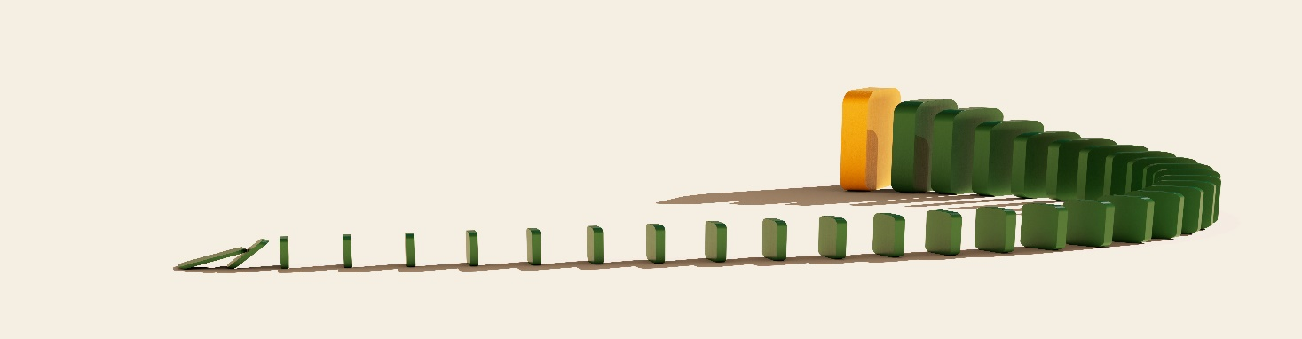

TEMS After School Domino Club is open to students in all grades. The club will meet in the library every other Tuesday starting September 17th from 3:15 PM to 4:15 PM. No previous experience is needed, and all abilities are welcome.

(September 17th, October 1st, October 15th, October 29th, November 12th, December 10th, January 7th, January 21st, February 4th, February 18th, March 4th, March 18th, April 1st, April 29th, May 13th, and May 27th)

Please sign below and include your email address for future communications.  Have your child return this completed form to Dr. Strohmetz in the library or scan/take a picture and email to [strohmetzj@tesd.net](mailto:strohmetzj@tesd.net) . You must have it to participate in meetings.

My student, _______________________________________, grade ________,

has my permission to participate in TEMS After School Domino Club. I understand that I will need to provide transportation home for my student at 4:15pm.

**Parent/Guardian signature: ______________________________________________________**

**Parent/Guardian printed name: __________________________________________________**

**Parent/Guardian phone number and email: _______________________________________________________________________**

**\*\* PLEASE RETURN THIS COMPLETED FORM TO Dr. Strohmetz in the library OR EMAIL TO** [**STROHMETZJ@TESD.NET**](mailto:STROHMETZJ@TESD.NET) **\*\***

***The Tredyffrin/Easttown School District charges an activity participation fee to offset some of the expenses of extra-curricular programs.  The established fee is $50, which covers participation in one or more sports or activities.  Any student who participates in one or more of these activities must pay the $50 fee.  Students participating in the free or reduced price lunch program will not be required to pay this fee.  For more information and a list of activities, please see:*** [***http://www.tesd.net/Page/8479***](http://www.tesd.net/Page/8479)

***The fee may be paid online or by mail.  Do not pay this fee at the schools, and do not submit payment to club advisors.***